**Lab 10: Flip Flops Conversion**

**Question 1: Modify the S-R flip flop created in last lab into JK flip flop. Verify the functionality of J-K flip flop using suitable Testbench.**

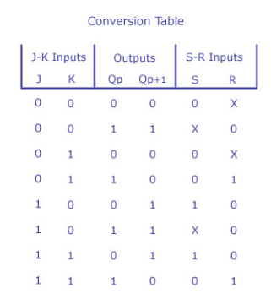

**Conversion Expression:** S = J’Q and R = KQ

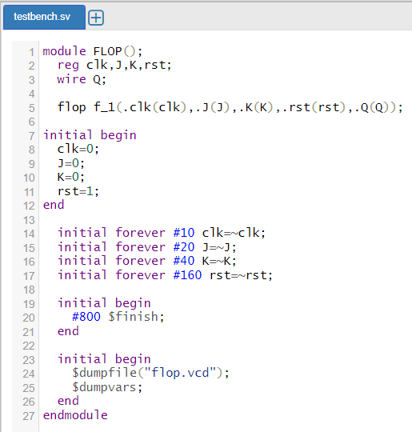 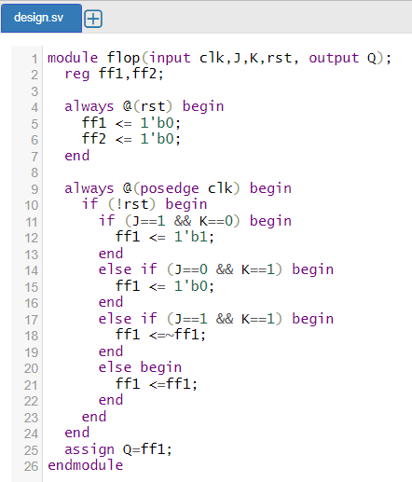



**Question 2: Develop the behavioural Verilog module of D flip-flop, converting it from a J-K flip flop. You may utilize if-else statements to develop your Verilog code. Verify the functionality via a suitable test bench code.**

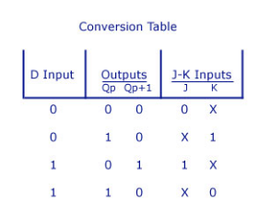

**Conversion Expression:** J = D and K = D’

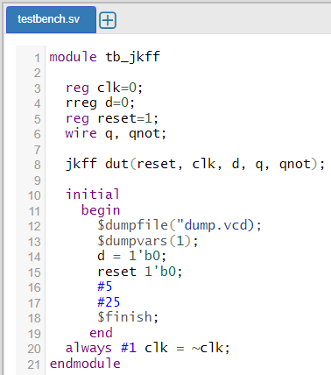 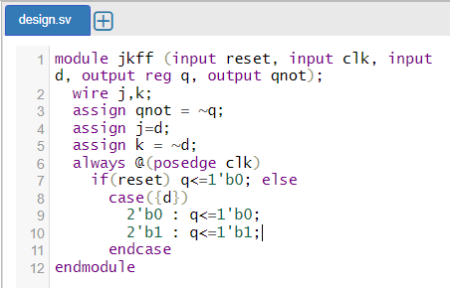

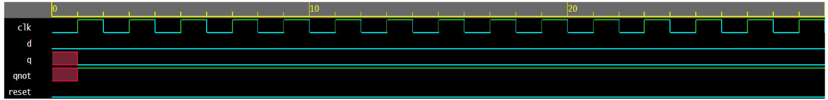

**Question 3: Develop a behavioural Verilog module for JK flip flop using case statements. Modify it to act like a T flip flop. Validate the modification via a suitable test bench.**

**Conversion Expression:** J = T and K = T



